FINAL REPORT

**Subjects: Quản trị mạng và hệ thống**

**Topic : Snort**

*GVHD: Trần Thị Dung*

**1.GENERAL INFORMATION:**

Class : NT132.N12.ATCL

|  |  |  |  |
| --- | --- | --- | --- |
| **STT** | **Họ và tên** | **MSSV** | **Email** |
| 1 | Trương Văn Rồng | 20521831 | 20521831@gm.uit.edu.vn |
| 2 | Lương Mạnh Tiến | 20522008 | 20522008@gm.uit.edu.vn |
| 3 | Phan Hoàng Nam | 20521635 | 20521635@gm.uit.edu.vn |

**2.CONTENTS:**

|  |  |  |
| --- | --- | --- |
| **STT** | **Công việc** | **Kết quả tự đánh giá** |
| 1 | I.Introduction | **100%** |
| 2 | 1.1 Overview | **100%** |
| 3 | 1.2 Component | **100%** |
| 4 | 1.3 Operation | **100%** |
| 5 | II. Implementation | **100%** |
| 6 | 2.1 Topology | **100%** |
| 7 | 2.2 Installation | **100%** |
| 8 | 2.3 Configuration | **100%** |
| 9 | III. Result | **100%** |
| 10 | 3.1 Basic model | **100%** |
| 11 | 3.2 Advance model | **100%** |
| 12 | Task | **100%** |
| 13 | Self - Assign | **100%** |

**Table Of Contents**

I. Introduction 2

1.1 Overview 2

1.2 Component 2

1.3 Operation 3

II. Implementation 4

2.1 Topology 4

2.2 Installation 5

2.3 Configuration 9

III.Result 10

❖ Basic result: 10

❖ Advance result: 13

Task 19

Self Assign 19

Answer 19

REPORT IN DETAIL

1. **Introduction**

**1.1 Overview**

Snort is a free open source Network Intrusion Detection System(NIDS) and Intrusion Prevention System (IPS) which is capable of performing real-time traffic analysis and packet logging on IP networks. It helps define malicious network activity and uses those rules to find packets that match against them and generates alerts for users, also prevent the intrusion.

Snort can be deployed inline to stop these packets, as well. Snort has three primary uses: As a packet sniffer like tcpdump, as a packet logger — which is useful for network traffic debugging, or it can be used as a full-blown network intrusion prevention system. Snort can be downloaded and configured for personal and business use alike.

**1.2 Component**

Snort is comprised of two major components: 5 modules and Rulesets.

5 modules are:

* Sniffer Module.
* Pre-Processor Module.
* Detect Engine Module.
* Alert and Log Module.
* Import/Export data Module

Rulesets:

Rule is a set of description languages, it works with the detection engine to detect the intrusion.

Rules can be written in /etc/snort/rules/local.rules

**1.3 Operation**

We can understand how Snort apply 5 modules by this image

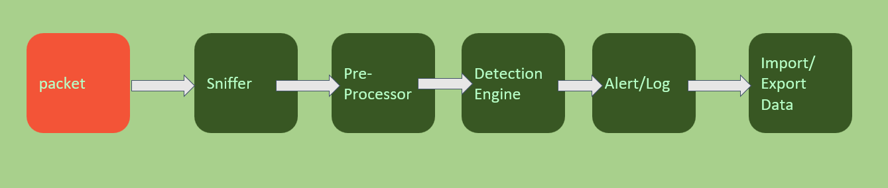

Packets which were sniffed by Snort will go into Sniffer module, then go into pre-processor to decode or format things. After that, it will go through the detection module, if there is any intrusion, it will pass to the alert/log module then eventually import or export the data.

Snort IPS uses rules that aids in the definition of malicious network activity and employs those rules to find packets that match against them, generating alerts for users

Each rule has a structure like this:

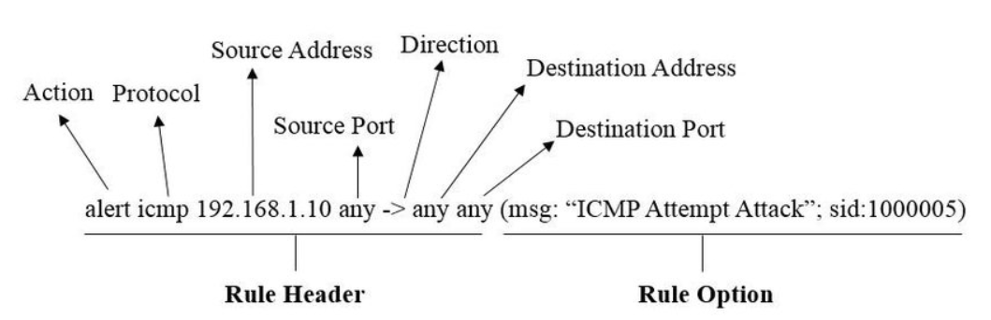

**Snort provides severals mode to operate:** - Sniffer mode.  
 - Logging mode.  
 - Network intrusion detection system mode.

* IPS Inline Mode

**II. Implementation**

**2.1 Topology**

**In basic model**:

Snort

server

Kali

Linux

Ubuntu

ping/nmap

* I configured the NAT network in VMware's Network Adapter in both Kali and Ubuntu machines.

**In advanced model:**

DVWA

Web

Snort

server

Web

Server

Host only

Bridge

Kali Linux

Ubuntu

Internet

* I configured the Bridge network in VMware's Network Adapter between the internet and Ubuntu machine
* In VMware's Network Adapter, I set up a Host-only network between the Ubuntu system and Kali Linux.

|  |  |  |
| --- | --- | --- |
|  | IP | Network |
| Ubuntu | 192.168.73.128 | Host only/ Bridge |
| Kali | 192.168.73.129 | Host only |
| Host | 192.168.73.1 |  |

**2.2 Installation**

* **Server:** Lubuntu (install snort)
* **Attacker:** Kali (use malicious network attacks)
* **In Ubuntu server**

**Step 1**:Before installing snort, make sure you have dev packages of libpcap and libpcre and have the lastest version apt install packet.

Use this command:

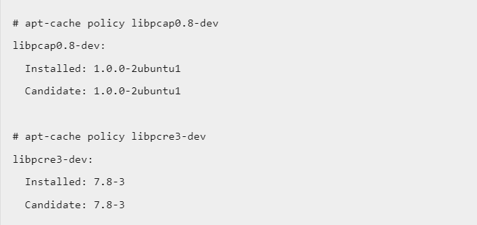

Then find the appropriate package for the operating system and install snort.

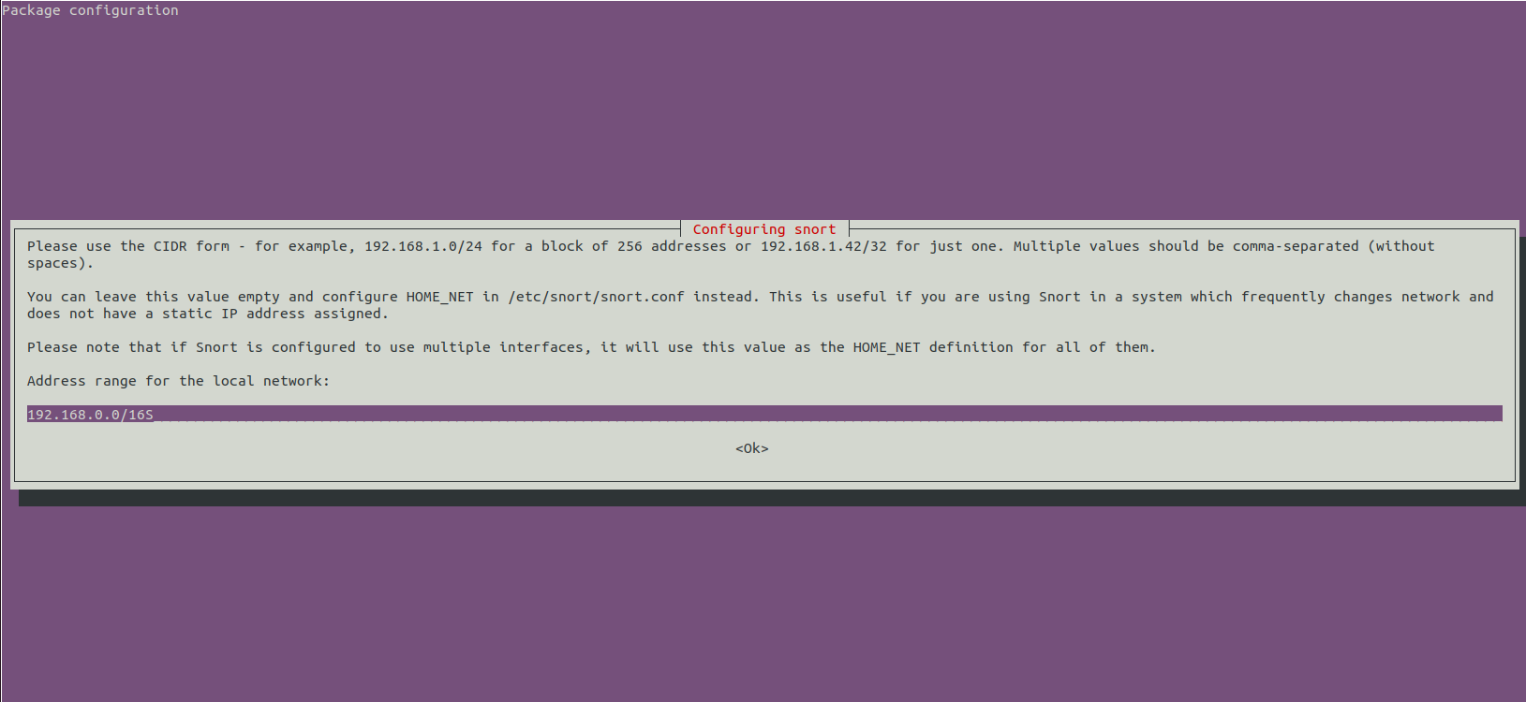

Select the address range for the local network and click Ok.

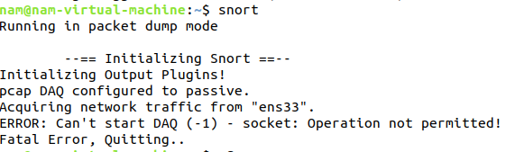

After successful installation. Check Snort version

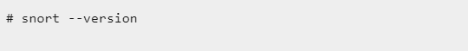

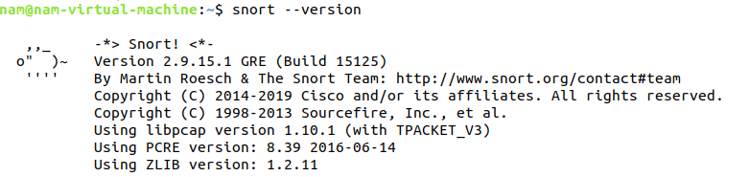

* **Next step**, Download and add snort rules
* To make the snort tool work, we need add the rules of snort.
* Can be downloaded directly on the snort site (supported by the community) using wget and saved and the communitu.tar.gz file

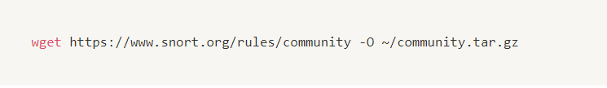

Extract the file with the tar . command

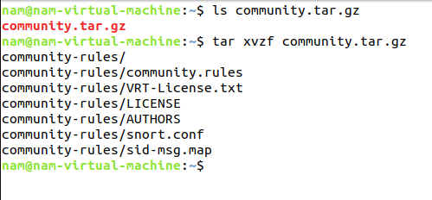

As a result, we can have the community-rules . directory:

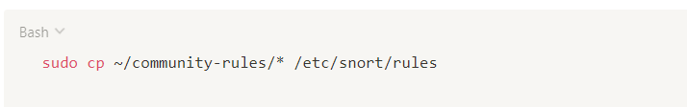

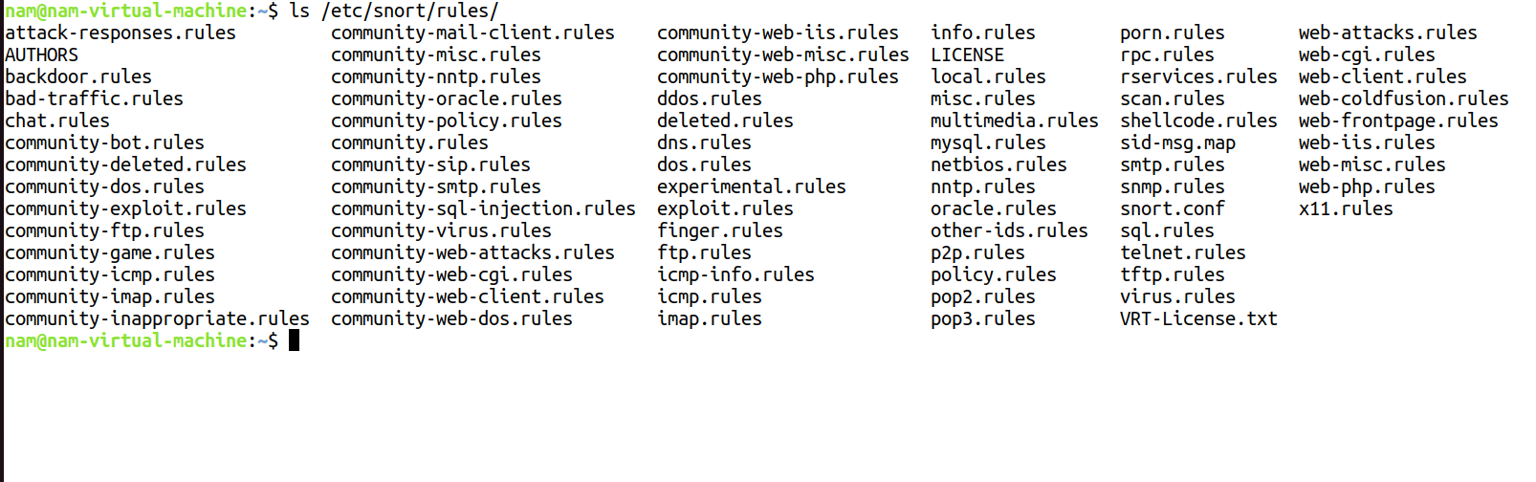

Test Snort:

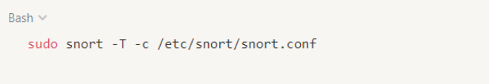

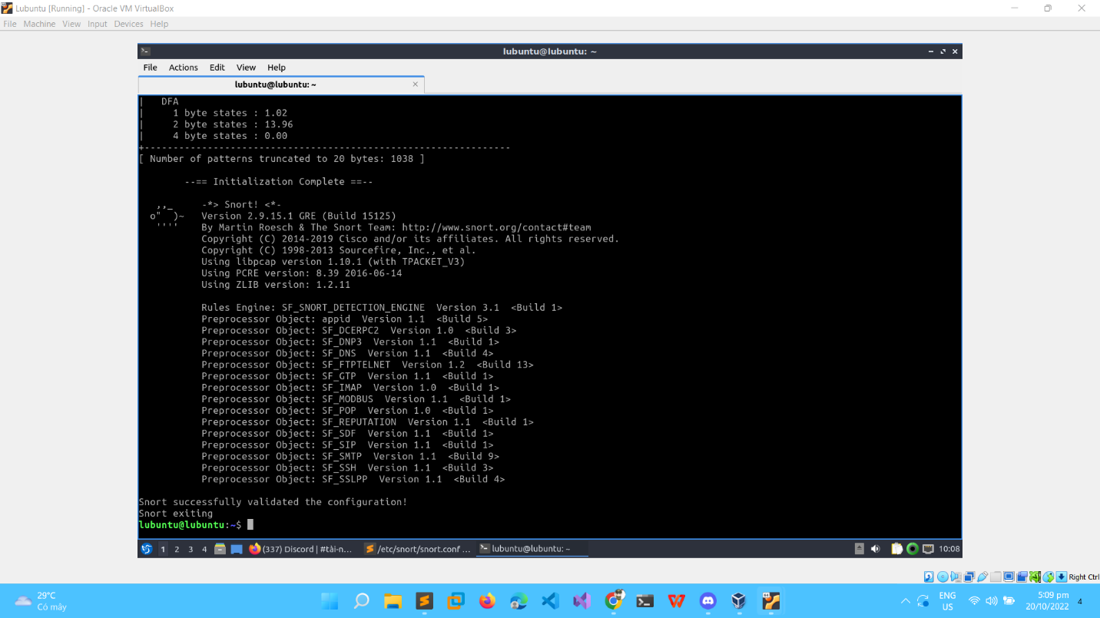

**2.3 Configuration**

Add this rule to file locals.local

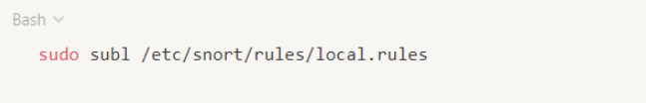

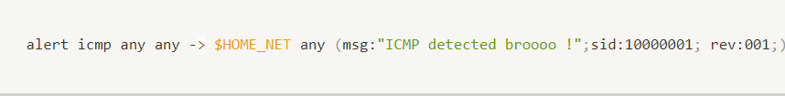

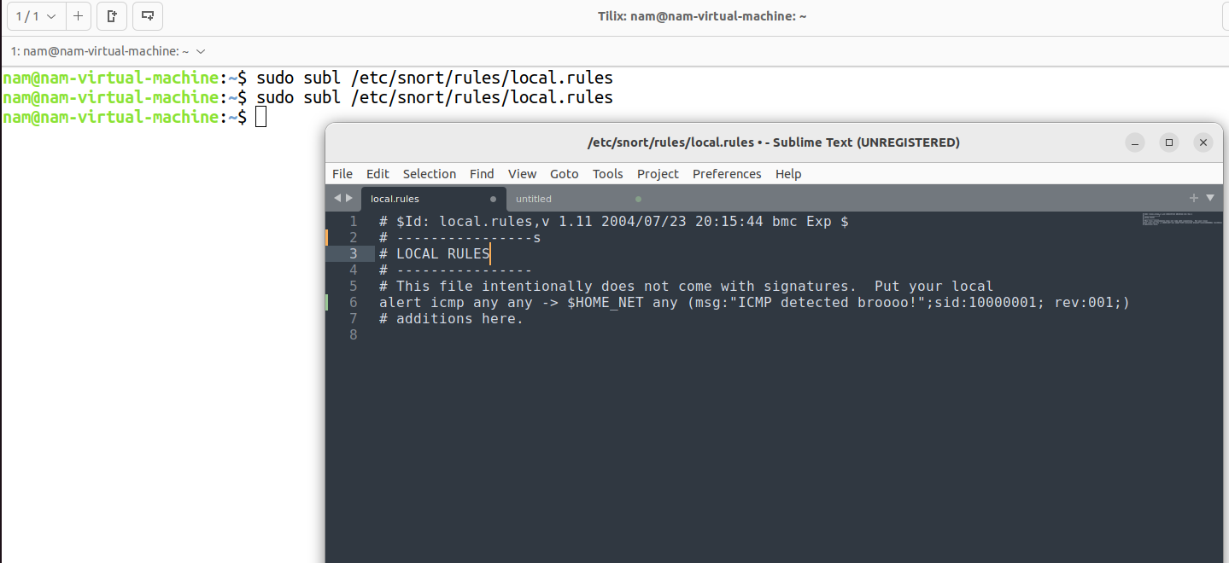

We try to ping and see result

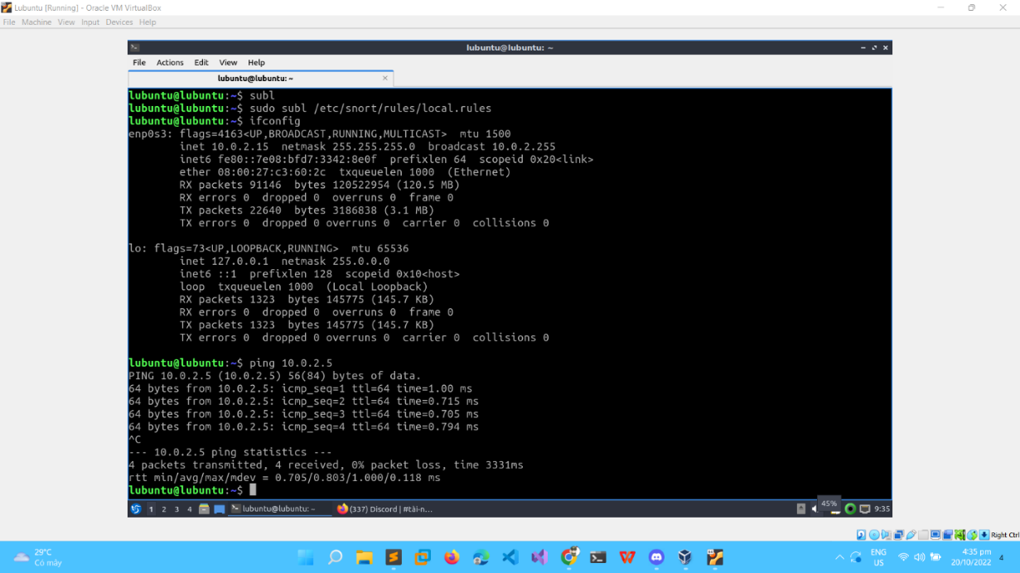

**III.Result**

* **Basic result:**

Kali VM:

* In Kali machine I use the ping command and ping to Ubuntu machine
* The ping command use ICMP protocol

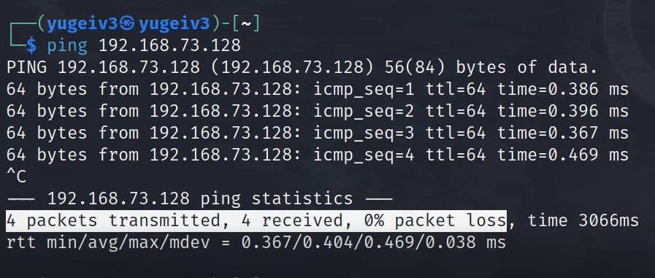

Ubuntu VM:

* I run this command to dectect the ping command from kali machine

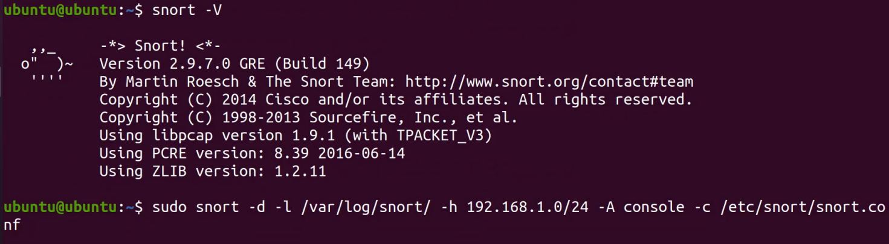

* When it receive the ping from kali machine, the snort can detect the malicious packet and then display in the screen (includes source IP, destination IP, protocol and the network attack command)

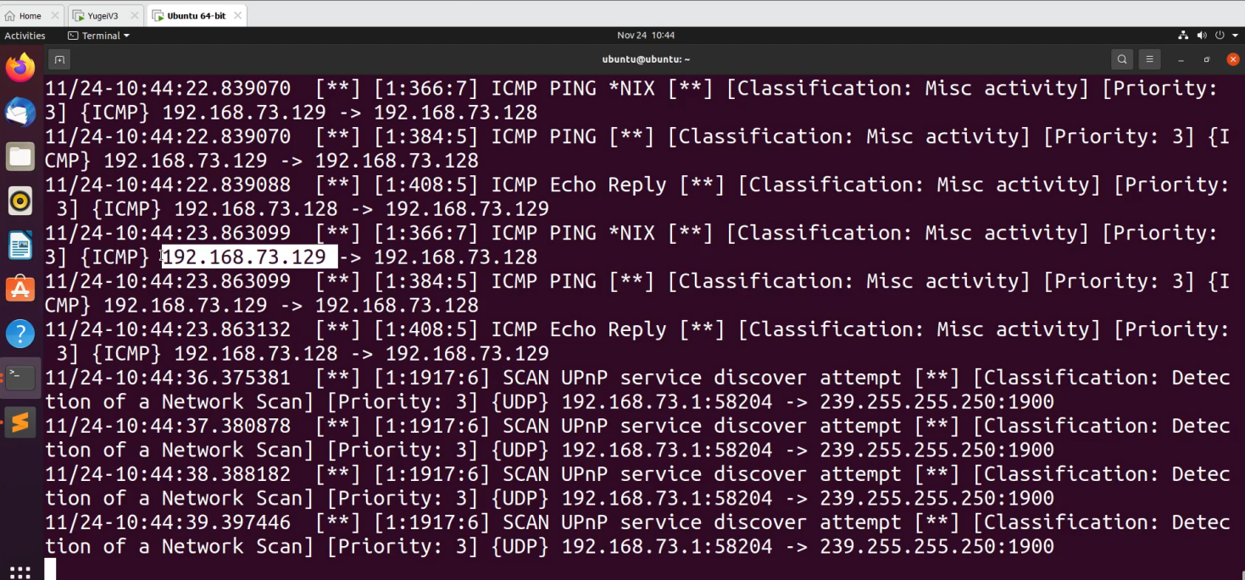

* After that I write the rule by myself to reject the ping command from kali machine by blocking that IP

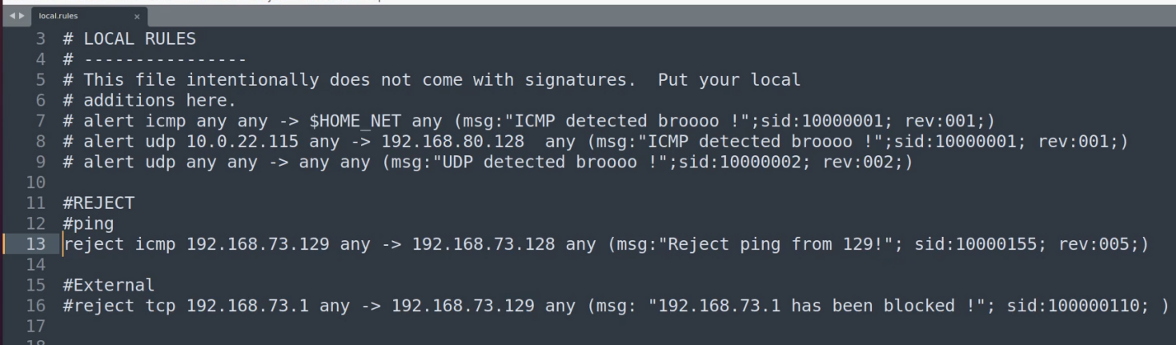

* Then I save the rule and run snort again
* Now in Kali machine can not ping to the Ubuntu machine

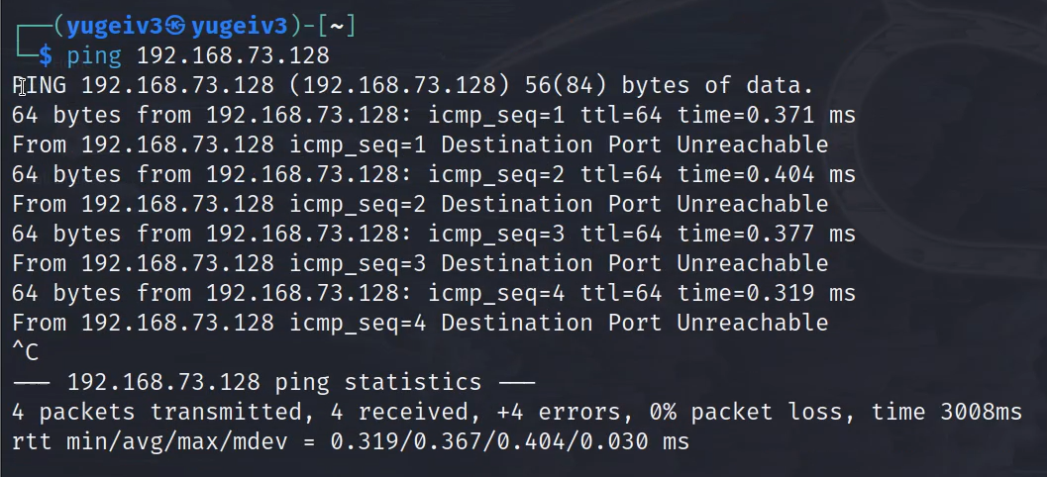

* In Unbuntu machine, it rejected the ping command from Kali machine

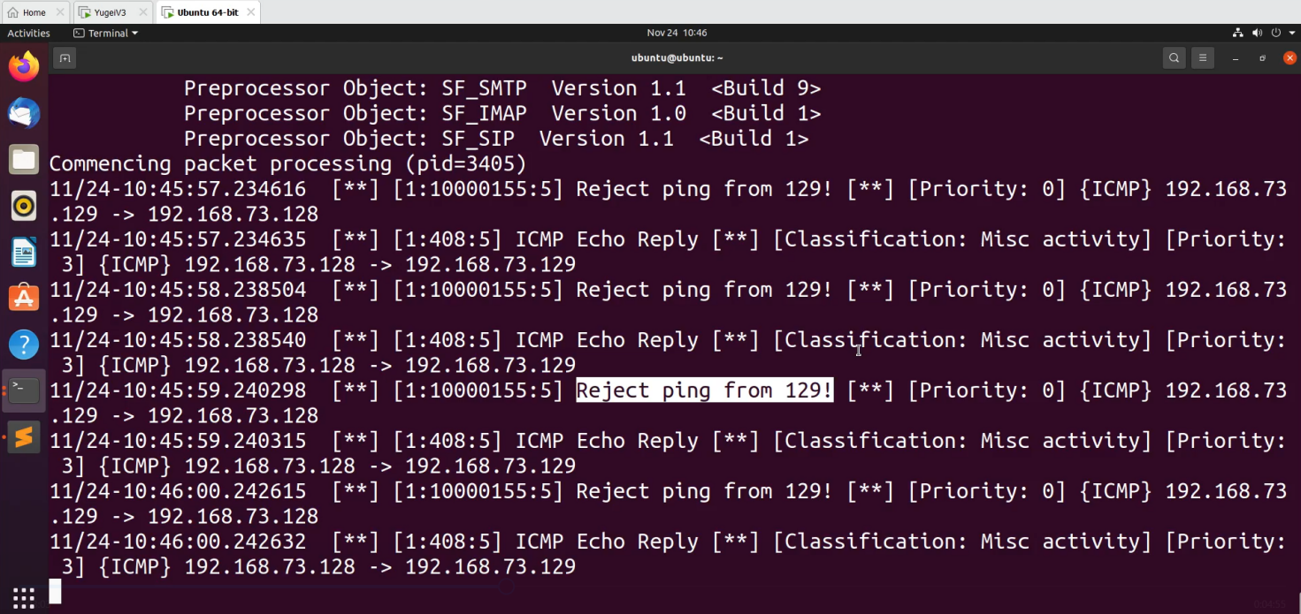

Thus, we have successfully detected and reject the attack using the ping command

* **Advance result:**
* In Kali machine I hosts the DVWA website by using docker

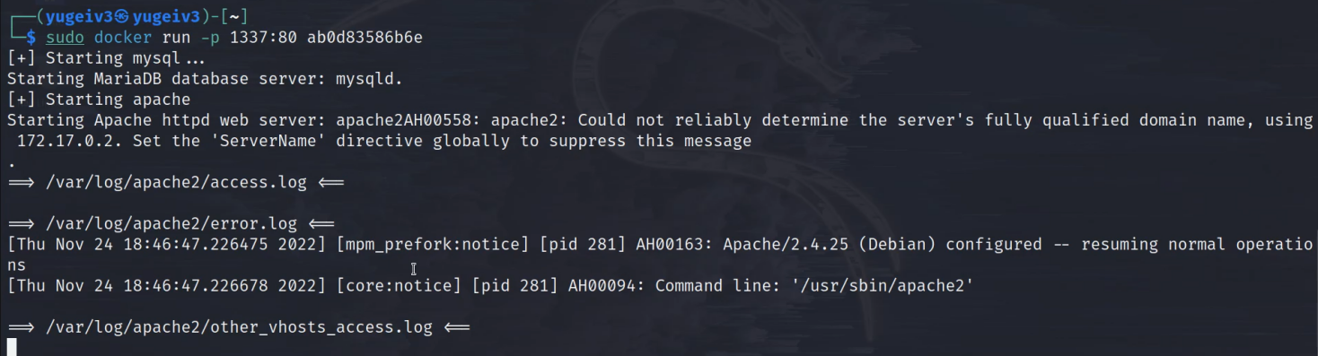

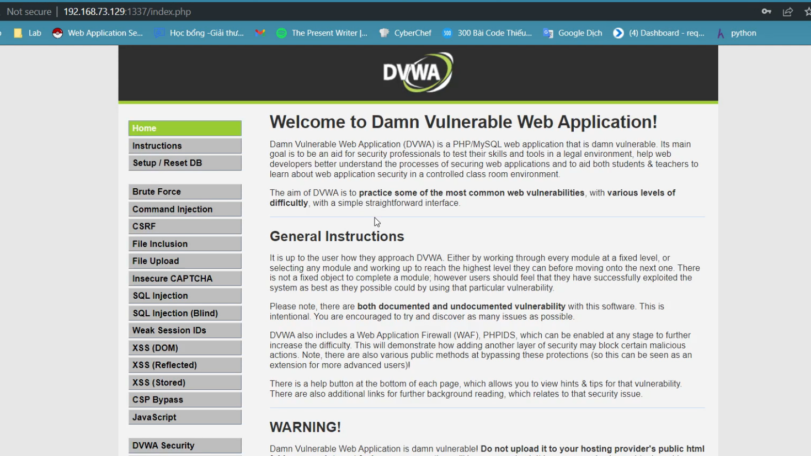

* I write the rule by myself to dectect the TCP protocol:

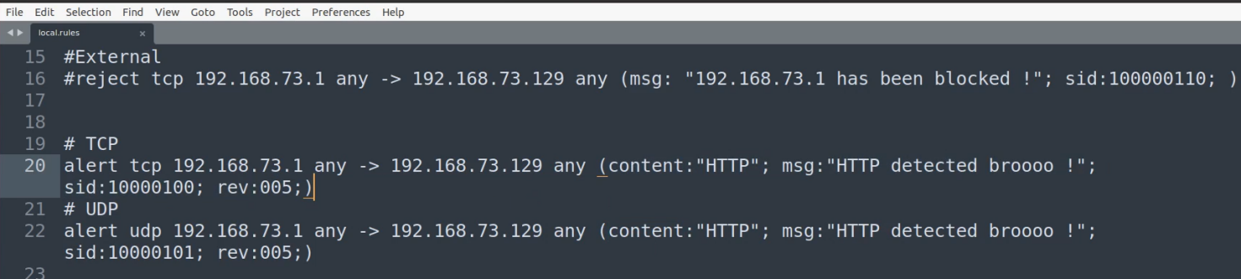

* Then I write some rules to detect the common vulnerabilities
* Such as SQLI, OS Command Injection, XXS
* I attack OS Command Injection in the website

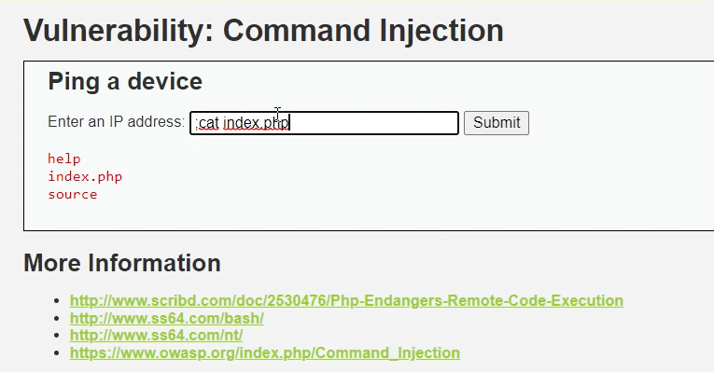

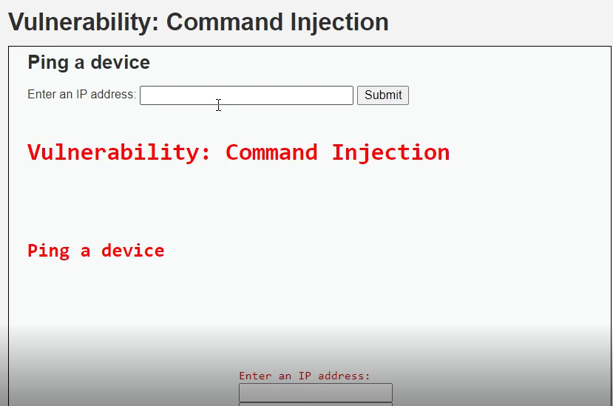

* Snort can detect the Os Command Injection by the rules which I wrote

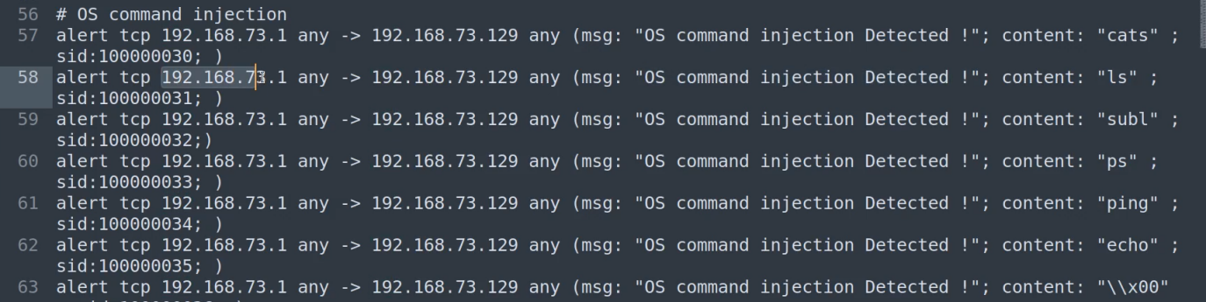

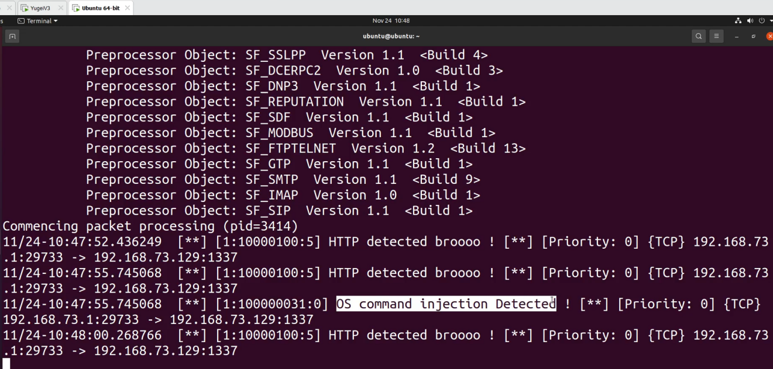

* I attack SQLi in the website

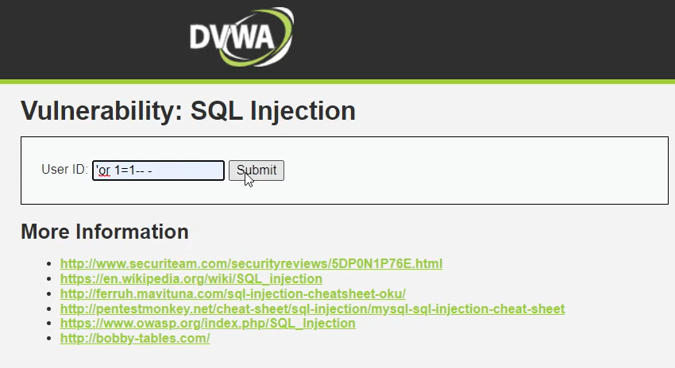

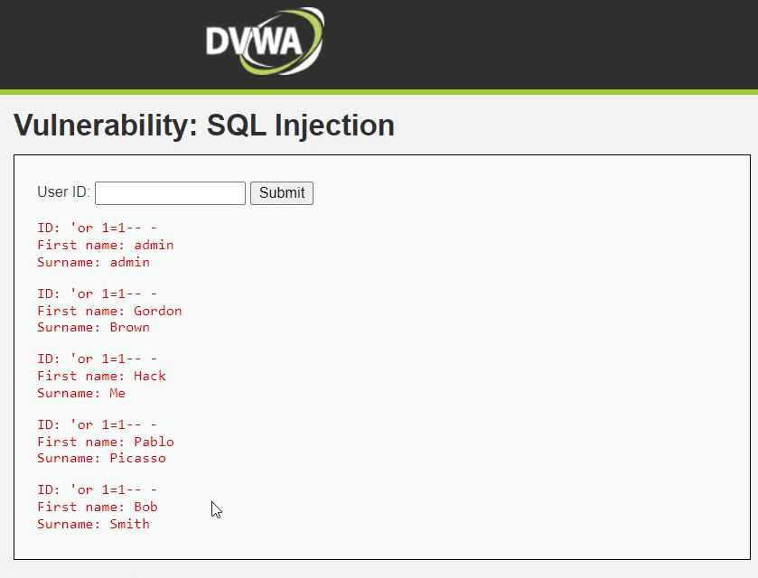

* Snort can detect the SQLi by the rules which I wrote

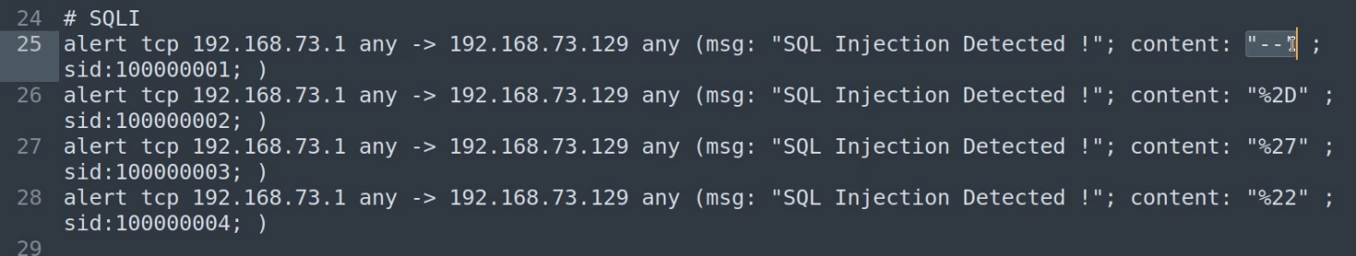

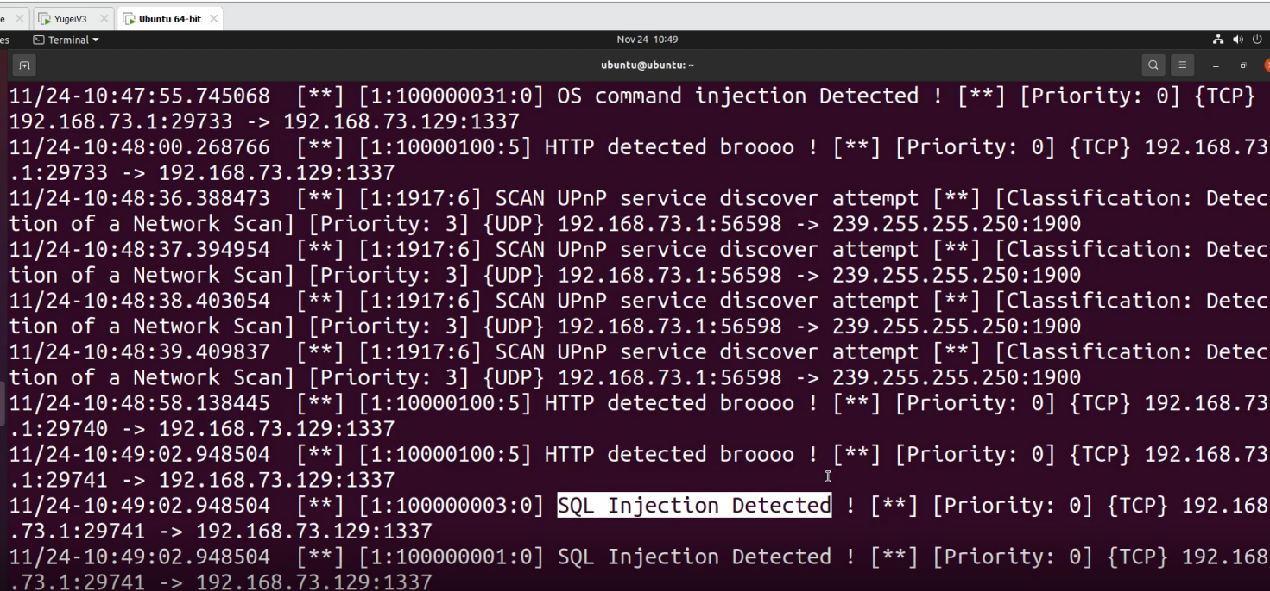

* Finally, I attack the website by XXS vulnerability

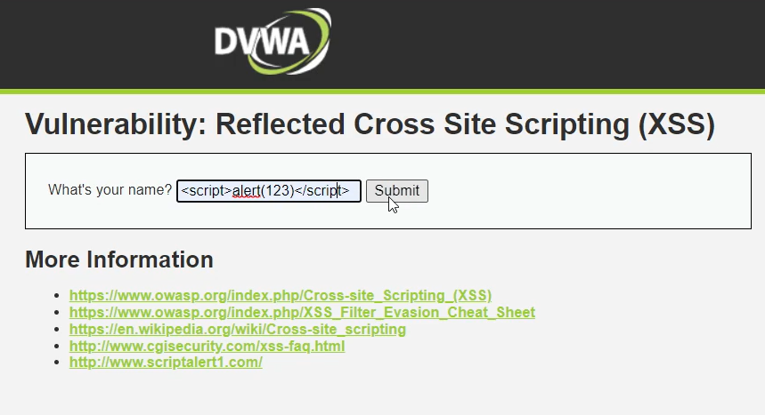

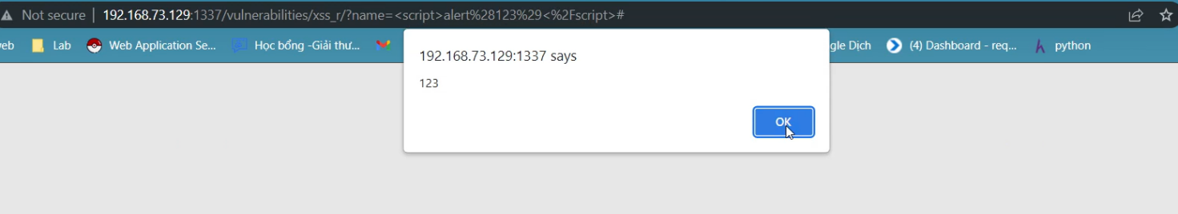

* Snort can detect XXS vulnerability

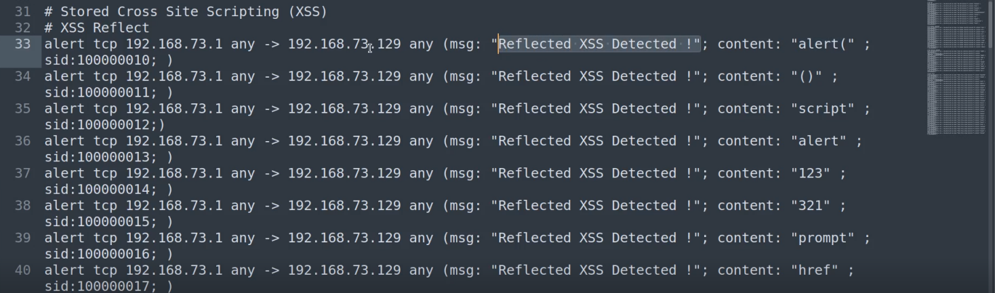

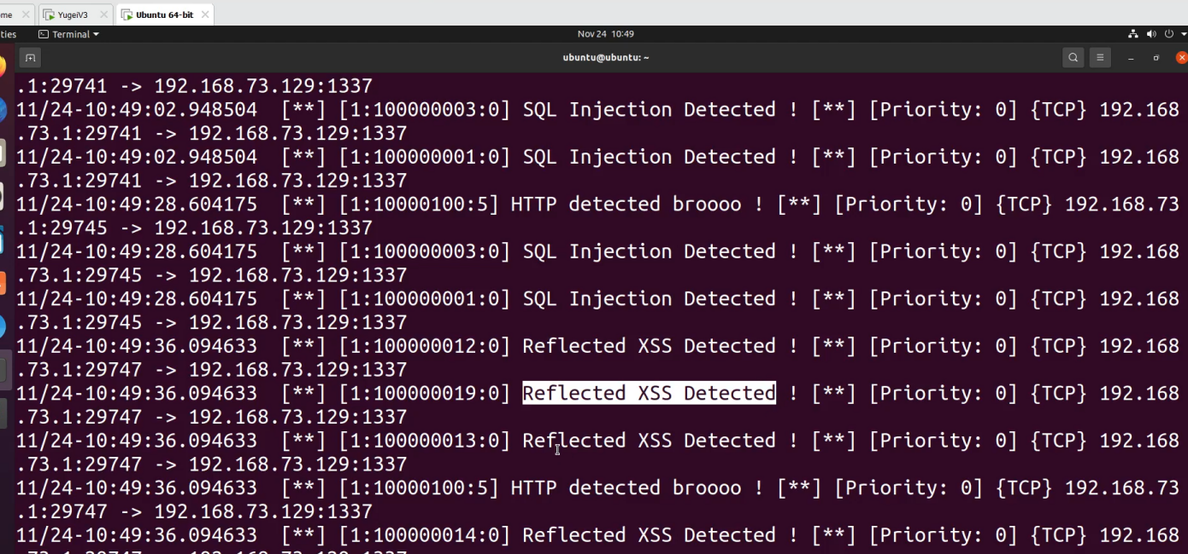

* Now I write the rule to block the IP which using malicious attack to Kali website

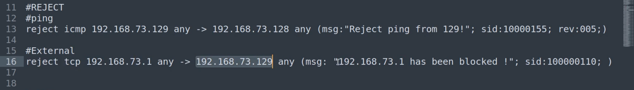

* So that the IP of host machine is blocked from our DVWA web site

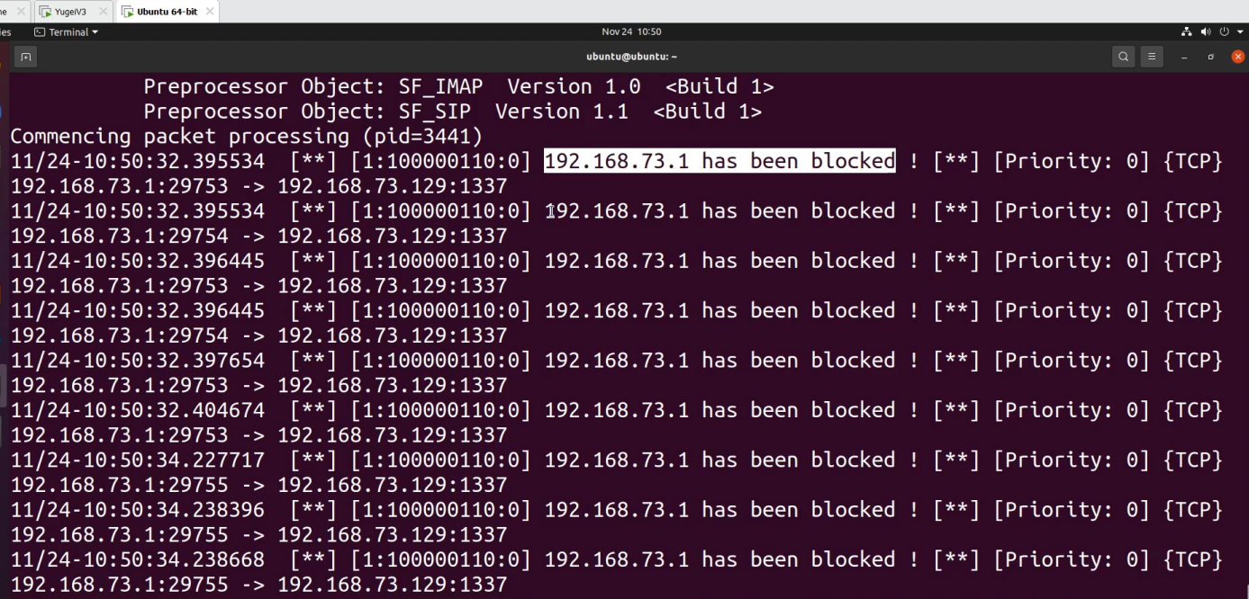

* Thus, we have successfully demo the advance model

**Task**

|  |  |  |
| --- | --- | --- |
| **ID** | **Task** | **Member** |
| 1 | * Technical research the basic and advance demo * Make slide and present the demo part * Write extra snort’s rules | Trương Văn Rồng |
| 2 | * Technical research the theory of snort * Make slide and present the first part * Make DVWA website in Kali machine | Lương Mạnh Tiến |
| 3 | * Research and config the IP of VM machines * Make slide and present the second part * Install snort and community rules | Phan Hoàng Nam |

**Self Assign**

|  |
| --- |
| * Evaluation of the level of completion against the implementation plan is: **100%** * Point: **10** |

**Answer**

Other group don’t have any question for our team. I just want to say this is a nice topic.

Thank you very much!

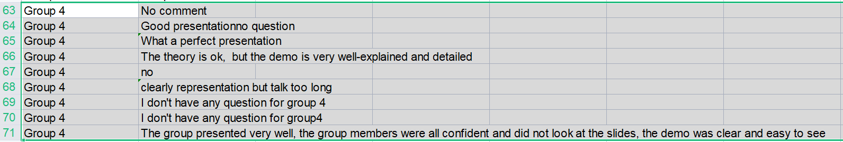

---

**END**